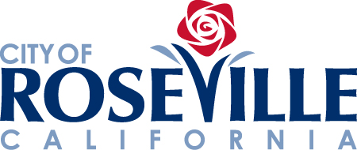

HOW TO VIEW YOUR SUPPLIER PORTAL ACCOUNT
STEP-BY-STEP REFERENCE GUIDE

Once a supplier portal account is activated on your behalf by the City, you will receive an auto-generated email containing your user ID and a link to reset your supplier portal password.
To request a supplier portal account, please follow the instructions provided on the ERP portion of the City of Roseville Procurement webpage.
Once you reset your password, follow the instructions below to view your organization’s account information.
TIP: Visit the ERP portion of the City of Roseville Procurement webpage to view additional supplier portal training materials (e.g., viewing a purchase order, viewing a payment, etc.)

Log into the Oracle Supplier Portal using your User ID and password.
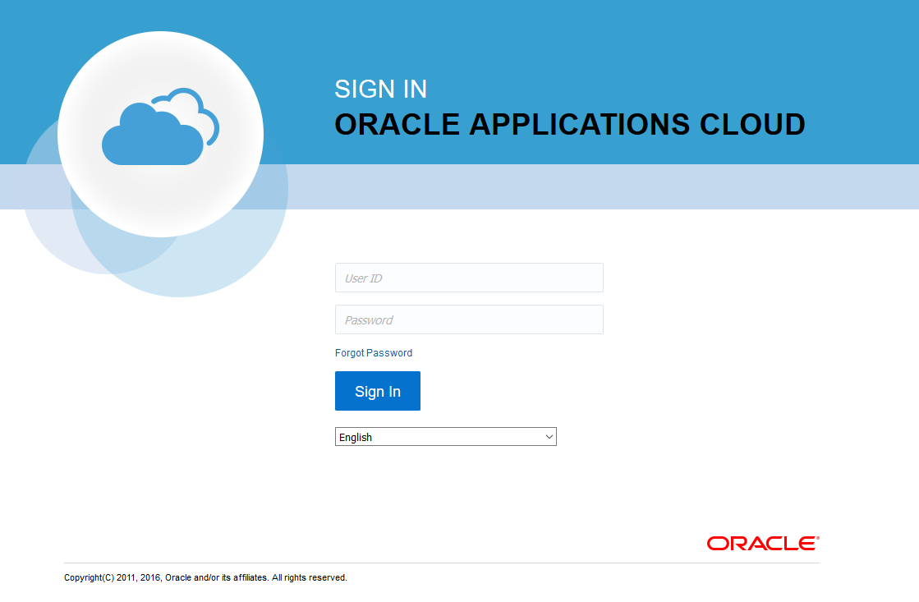
Click the Supplier Portal icon from the home page.
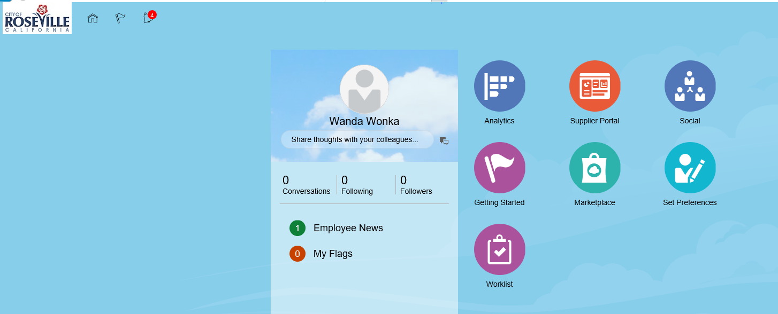

From the Supplier Portal main page, select Manage Profile.
TIP: Scroll down if you are unable to see the Manage Profile link.
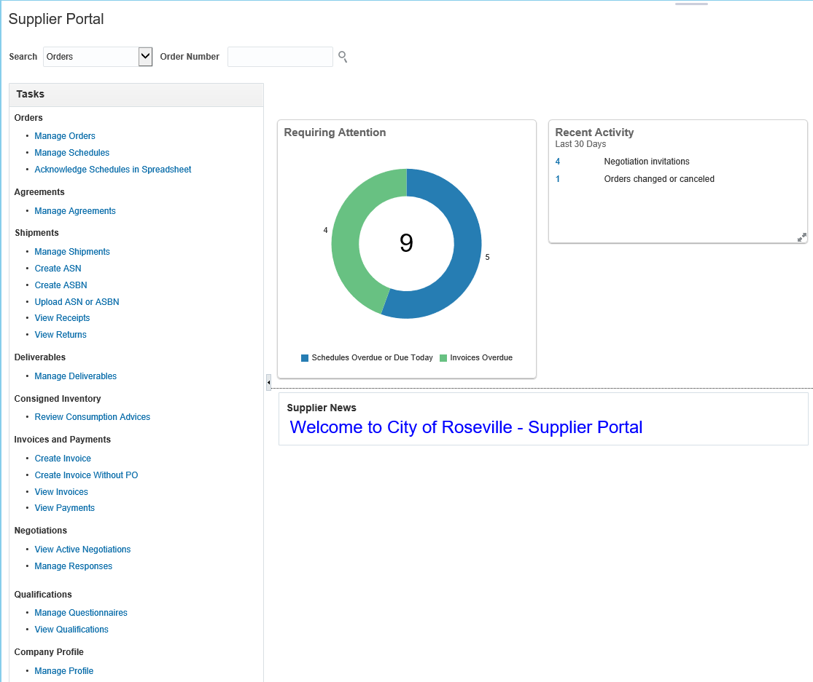
Once at the Company Profile page, click through each category (in blue) to view your organization’s information. The following information includes tips for reviewing your information for a few of the categories.

At this time, companies are not able to edit their profile. If you need to make modifications to your account, please send an email to supplierportalquestions@roseville.ca.us.

Addresses
Your company profile may list multiple addresses for different purposes (e.g., remit, orders, etc.), or for different locations.
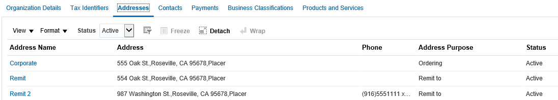
Address3
Address2
Address1
Contacts
Multiple Contacts for your company may be listed.
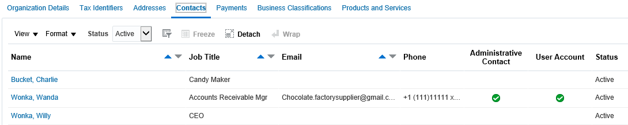
Roles
If you are a Prospective Supplier, not actively doing business with the City, you will be assigned a “Supplier Bidder” role which allows for participation in informal online bidding.*
If you are actively doing business with the City, you will be assigned the “COR Supplier Account Receiving Specialist,” “Supplier Bidder,” and Supplier Customer Service Representative” roles.

* Please note the City is currently not using the informal bidding feature, but will be implementing it in the near future.

Payments
Your company payment method and account information is listed.
Products and Services
The City uses the National Institute of Governmental Purchasing (NIGP) codes to categorize good and services.
Your company’s NIGP codes will be listed in the Products and Services section.
City employees searching for suppliers of certain goods or services can perform a search by product category to view which suppliers provide a particular good or service.

Changes to Account Information
If you need to make modifications to your account, please email supplierportalquestions@roseville.ca.us.
Once the requested changes are made, you will receive an email confirming the changes to your account.

